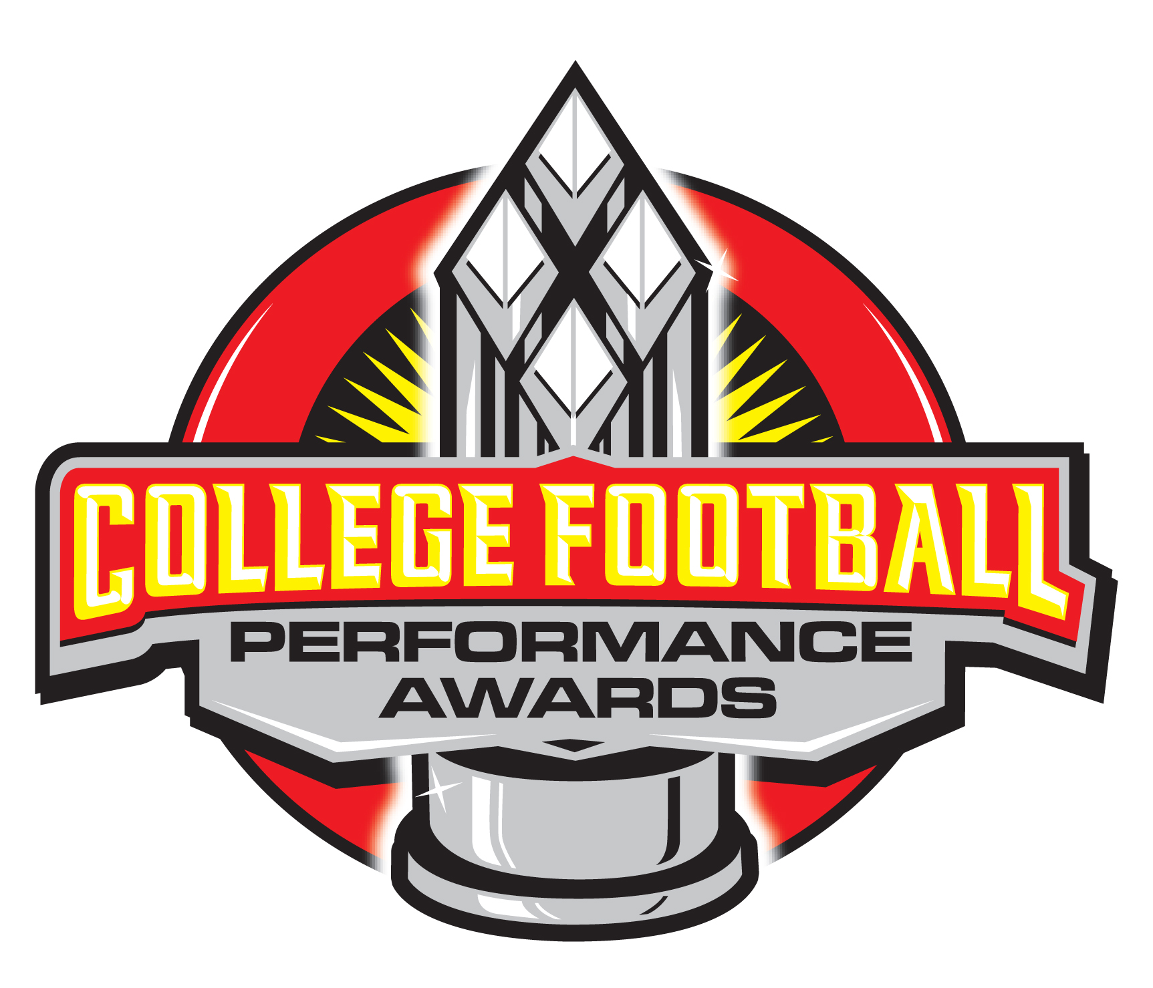
COLLEGE FOOTBALL PERFORMANCE AWARDS
2010 DIVISION I FCS PRESEASON FAVORITES
*The following is a rough watch list for the 2010 season. All Division I FCS players are eligible for awards at their respective positions. The following list is not intended to represent order by institution or name.
FCS National Performer of the Year: Jeremy Moses (Stephen F. Austin), Michael Herrick (Northern Arizona), Scott Riddle (Elon), Chase Reynolds (Montana), Taiwan Jones (Eastern Washington), Matt Szczur (Villanova), Devon Moore (Appalachian State), Tysson Poots (Southern Utah), K.J. Black (Prairie View), Andrew Selle (Montana), Thomas DeMarco (Old Dominion), Chris Whitney (Villanova), Josh McGregor (Jacksonville)
FCS Defensive Performer of the Year: Malcolm Taylor (Alcorn State), Jason House (Southern), Matt Parker (St. Francis-PA), Dejuan Fulghum (Texas Southern), B.W. Webb (William & Mary), Dain Taylor (Drake), Christian Clark (Sacramento State), Kendrick Ellis (Hampton), Donovan Robinson (Jackson State), Ibrahiam Abdulai (Arkansas Pine-Bluff), Christian Anthony (Grambling), Martin Parker (St. Francis-PA)
FCS Quarterback Performer of the Year: Jeremy Moses (Stephen F. Austin), Michael Herrick (Northern Arizona), Scott Riddle (Elon), Josh McGregor (Jacksonville), K.J. Black (Prairie View), Andrew Selle (Montana), Thomas DeMarco (Old Dominion), Chris Whitney (Villanova)
FCS Running Back Performer of the Year: Kyle Minett (South Dakota State), Taiwan Jones (Eastern Washington), Chris Evans (Samford), Chase Reynolds (Montana), Devon Moore (Appalachian State), Rudell Small (Jacksonville), Ed Gowins (Stony Brook), Justin Babb (Savannah State), Patrick Hall (Gardner-Webb), Mario Crawford (Old Dominion), Mike Rucker (Wofford), Terrence Holt (Austin Peay), Matt Szczur (Villanova)
FCS Wide Receiver Performer of the Year: Tysson Poots (Southern Utah, James LaMacchia (Marist), Da’Marcus Griggs (Texas State), Joshua Philpart (Jacksonville), Raymond Fry (Portland State), Simmie Yarbrough (Southeastern Louisiana), Fesi Sitake (Southern Utah), Zach Watkins (Butler), Mark Layton (Lafayette), Lito Senatus (Western Illinois), Dominique Johnson (Cal Poly), Brandyn Reed (Sacramento State), Nick Andrews (Alabama State), Dominique Barnes (Youngstown State)
FCS Tight End Performer of the Year: N/A
FCS Defensive Lineman Performer of the Year: Christian Anthony (Grambling), Dain Taylor (Drake), Malcolm Taylor (Alcorn State), Christian Clark (Sacramento State), Kendrick Ellis (Hampton), Donovan Robinson (Jackson State), Ibrahiam Abdulai (Arkansas Pine-Bluff), Shaun Lewis (Jacksonville), Grant Hunter (Butler), Jared Green (MVSU), Renard Williams (Eastern Washington), Yaky Ibia (Towson)
FCS Linebacker Performer of the Year: Matt Parker (St. Francis-PA), Dejuan Fulghum (Texas Southern), Josh Bey (Tenn-Martin), Brandon Pequese (Hampton), Shomari Clemons (Texas Southern), Ben Morrison (Drake), Marty Patterson (Gardner-Webb), Rob Damon (Rhode Island), Keith Pough (Howard), Loka Kanonqataa (San Diego), David Akinniyi (Northeastern), Steven Cody (Princeton), Ryan Rich (Jackson State)
FCS Defensive Back Performer of the Year: Jason House (Southern), B.W. Webb (William & Mary), Tyler Moorehead (Drake), Josh Norman (Coastal Carolina), Jeremy Caldwell (Eastern Kentucky), E.J. Jones (Illinois State), Curtis Thomas (Texas Southern), T.J. Heath (Jacksonville State), Korey Morrison (Alabama A&M), Mike McElroy (Southern Illinois), Mark LeGree (Applachian State), Matt Johnson (Eastern Washington), Adam Mehrer (Columbia), Justin Ferrell (N.C. A&T), Jacquan Bryant (Marist), C.J. James (Eastern Illinois)
FCS Punter Performer of the Year: Jonathan Plisco (Old Dominion), Pedro Ventura (Prairie View), Patrick Dolan (Nicholls State), Kyle Negrete (San Diego), Kevin Cook (Eastern Illinois), Tim Edger (Rhode Island), Drew Nelson (Stephen F. Austin), Bob Hooper (Samford), Josh Duran (Southern), Sean Wren (Montana)
FCS Punt Returner Performer of the Year: Kiare Thompson (Grambling), Fesi Sitake (Southern Utah), Alan Bonner (Jacksonville State), Terrence Holt (Austin Peay), Quan Long (N.C. A&T), Todd Speight (Western Illinois), Champlain Babin (McNeese State), Elliott Finkley (Jacksonville)
FCS Kickoff Returner Performer of the Year: Mareo Howard (Arkansas Pine-Bluff), Matt Szczur (Villanova), Darrius Gates (Indiana State), Garry Coles (Sacred Heart), Marcus Harris (Murray State), Frantz Placide (Wagner), Andrew Smith (Albany), Larrone Moore (Delaware State)
FCS Placekicker Performer of the Year: Chris Diniz (Sacramento State), Matt Cesari (Furman), Mike Levine (San Diego), Matt Bevins (Liberty), Ari Johnson (Grambling), Zach Brown (Portland State), Matt Myers (Northern Arizona), Evan Engwall (Stephen F. Austin), Kyle Dougherty (Southern Illinois), Wesley Skiffington (Stony Brook), Kienan Cullen (Murray State), Jon Striefsky (Delaware), Garrett Clawson (Robert Morris)

